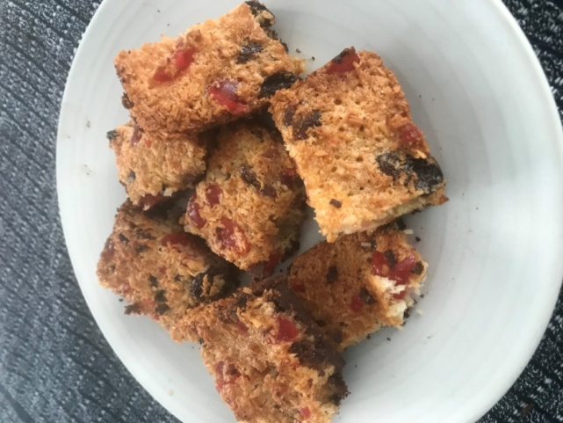

**Picnic slices**

**Ingredients**

* 220g (8 oz) chocolate ( broken into pieces)
* 50g (2 oz) butter or margarine
* 100g (4 oz) caster sugar
* 1 egg, beaten
* 100g (4 oz) desiccated coconut
* 50g (2 oz) sultanas
* 50g (2 oz) glacé cherries, quartered

**Instructions**

* Preheat oven to 150 C (gas 2)
* Grease a 30 x18 cm baking tray and line with parchment / greaseproof paper
* Melt the chocolate pieces in a bowl over a pan of hot water*
* Pour the chocolate into the baking tray and spread evenly to make the base
* Chill in the fridge until set.
* Put the sugar and butter into a bowl and cream until light and fluffy.
* Add the beaten egg, the coconut, sultanas and cherries and mix well.
* Take the set chocolate base from the fridge
* Spread the mixture evenly over the chocolate
* Bake for 30 minutes, until firm.
* Remove from oven and mark into squares after 5 minutes.
* You can return to the fridge to set.

*You can use a microwave to melt the chocolate. Using a microwave safe bowl – microwave the chocolate ( high) in 30 second bursts. Keep stirring until chocolate is melted and smooth

**Chocolate mousse**

**Ingredients**

* 150g 70% [dark chocolate – broken into pieces](https://www.bbcgoodfood.com/glossary/dark-chocolate)
* 6 egg whites
* 2 tbsp golden caster sugar
* 4 tbsp crème fraîche and grated chocolate, to serve

Topping - chocolate sprinkles or grated chocolate to serve

**Instructions**

1. Put the chocolate pieces in microwave safe bowl.
2. Melt the chocolate in the microwave - stir every 30 seconds until just melted.
3. Whisk the egg whites to soft peaks, sprinkle in the sugar and whisk again until the mixture forms stiff peaks when you lift the whisk out (around 30 seconds).
4. Add a big tablespoon of the egg white to the melted chocolate and mix quickly, so the chocolate doesn’t cool and harden.
5. Then fold in the remaining egg whites carefully using a spatula or large metal spoon. Spoon into 4 glasses or ramekins and set in the fridge for 2-3 hours.
6. Serve with a spoonful of crème fraiche and grated dark chocolate.

**Peanut butter cookies**

**Ingredients**

* 45 g smooth peanut butter
* 50 g soft butter
* 50 g caster sugar
* 45 g light brown sugar
* 1 beaten egg
* 100 g plain flour
* 10 g baking powder
* grated zest from the quarter of orange
* 50 g chopped unsalted peanuts

**Method**

1. Preheat the oven to 180°C/gas 4.
2. In a mixing bowl, cream together the peanut butter, butter, caster sugar and light brown sugar until well-blended. ( about 4 minutes)
3. Add in the beaten egg and mix for a further 2 minutes.
4. Add the flour, orange zest and baking powder, then mix in the peanuts.
5. Divide the mixture into 20 even-sized balls and place them onto a lined baking sheet ( leave spaces between each ball)
6. Press each ball lightly with a fork.
7. Bake for 25 minutes until set.
8. Leave to cool before serving